









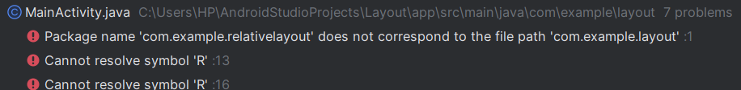

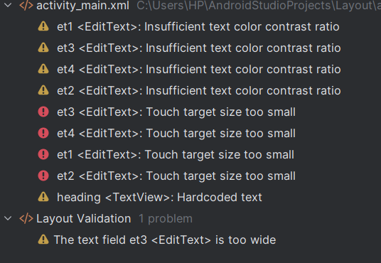



**Implementation Phase: Final Output(no error)**

**Step 1: Create a New Project**

**Select "Empty Activity" and click Next.**

**Enter the project details:**

* + **Name: Layout**

**Modify Strings.xml**

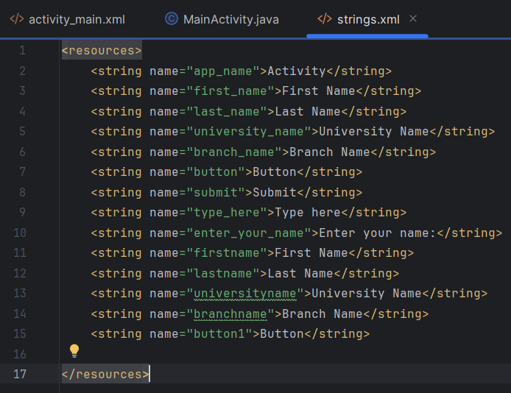

**Implementation Phase: Final Output(no error)**

**Step-2: Linear Layout**

* **Open activity_main.xml and set the root layout to <LinearLayout>.**

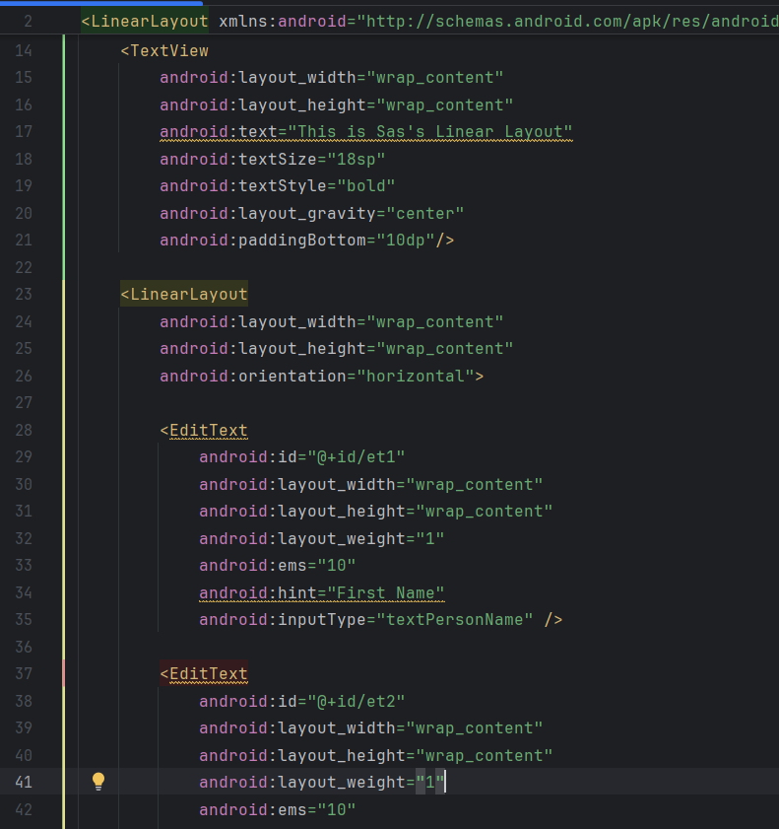 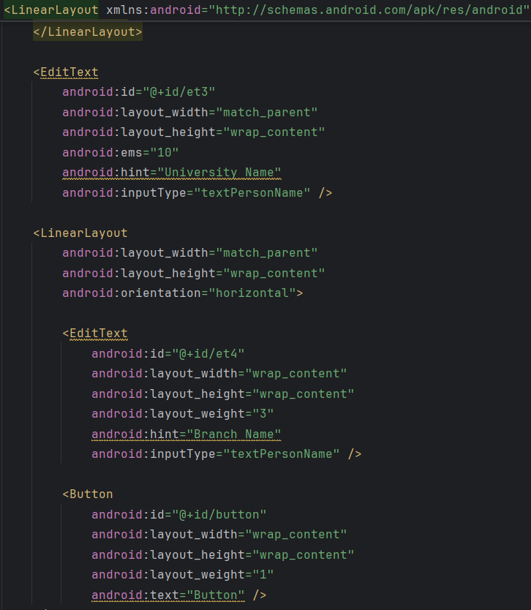

* **Add TextView, EditText, and Button elements sequentially.**
* **Modify MainActivity.java**

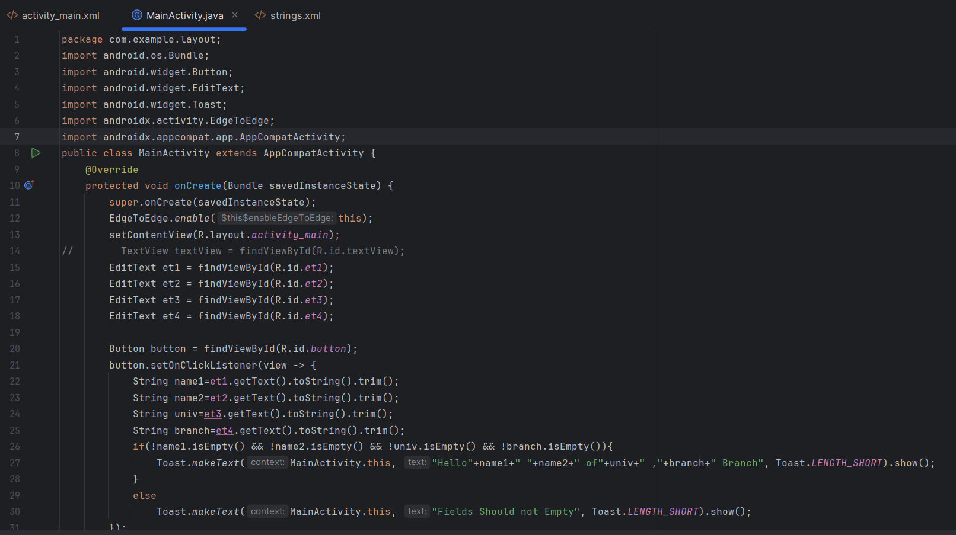



**Implementation Phase: Final Output(no error)**

**Step-2: Relative Layout**

* **Open activity_main.xml and set the root layout to <RelativeLayout>.**

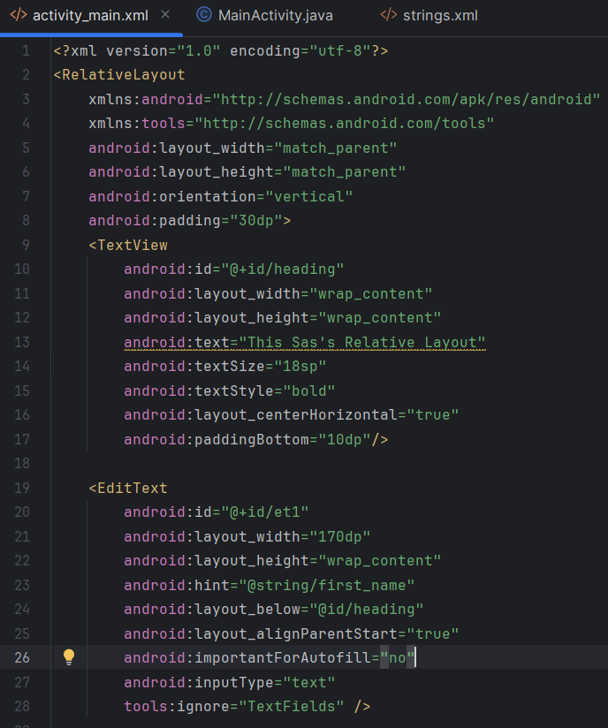 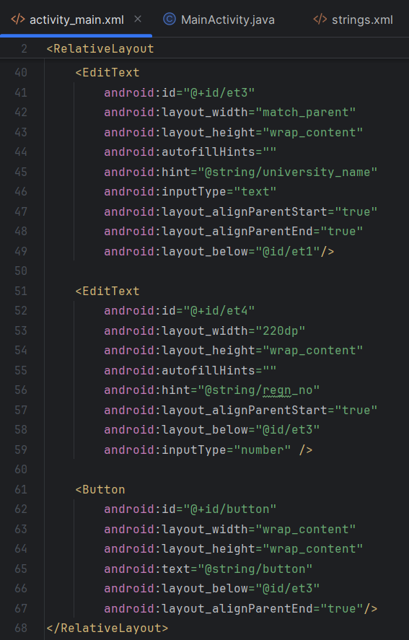

* **Add TextView, EditText, and Button elements sequentially.**
* **Modify MainActivity.java**



**Implementation Phase: Final Output(no error)**

**Check the layout preview**

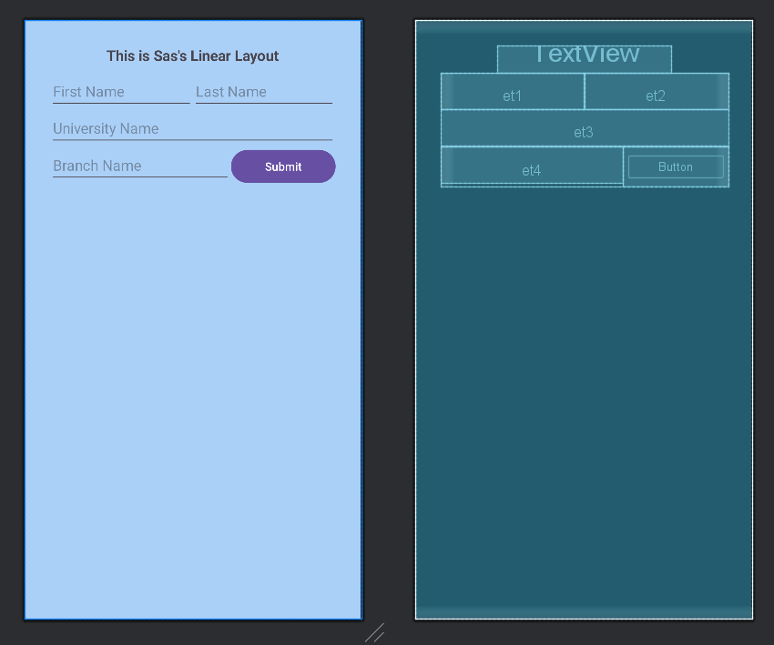

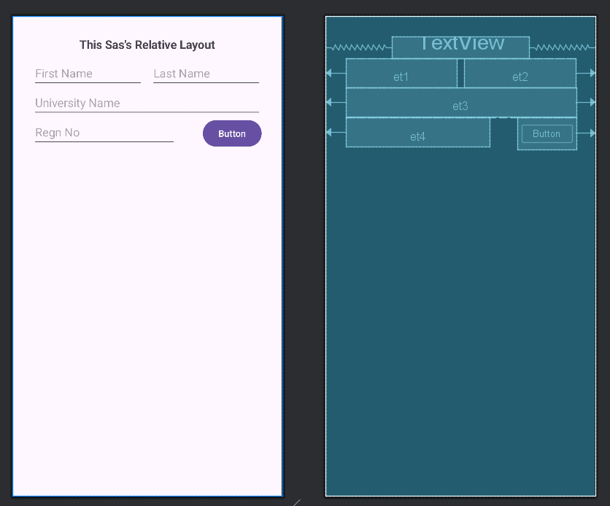



1. **Click Run**
2. **Select an emulator or a connected Android device.**





        
        
        
        
        
        
        
        
        

